In the Data Science VM, execute the following steps to prepare for the lab

- Download Putty 64bit MSI from their download page
- Install Putty in the default folder and follow steps to complete installation
- Copy the SSH-Keys.zip file in your DSVM Desktop and unzip it there.
- From Putty test connection to the HDInsight Edge Node, using ssh keys from above.
Screenshots below
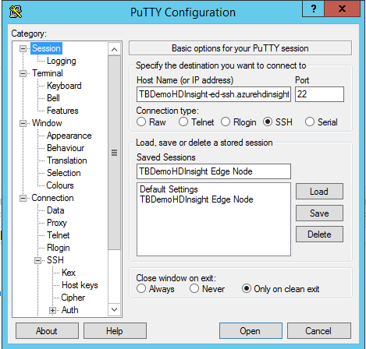
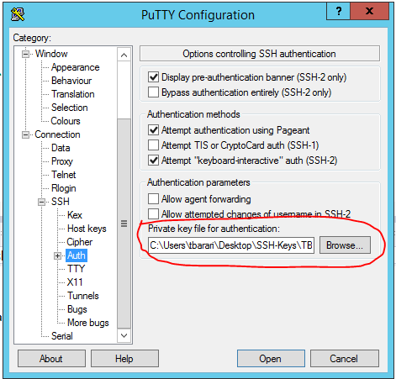

- From your DSVM download and install latest MS R Client (3.3.3) from here. If you need to learn more, details are in this page.
- Open Visual Studio (VS) and sign-in to your account (could be trial account)
- In VS, top menu, select R Tools->Data Science Settings, to use the R environment
- Copy the R-HDInsight-LocalDirectory.zip file in your DSVM Desktop and unzip it there.
- In VS, run the R code from labScript.R

